Social Network Analysis

Aya Ben hriz

26/11/2021

## Load packages  
library(igraph)

##   
## Attachement du package : 'igraph'

## Les objets suivants sont masqués depuis 'package:stats':  
##   
## decompose, spectrum

## L'objet suivant est masqué depuis 'package:base':  
##   
## union

library(readr)  
library(dplyr)

##   
## Attachement du package : 'dplyr'

## Les objets suivants sont masqués depuis 'package:igraph':  
##   
## as_data_frame, groups, union

## Les objets suivants sont masqués depuis 'package:stats':  
##   
## filter, lag

## Les objets suivants sont masqués depuis 'package:base':  
##   
## intersect, setdiff, setequal, union

library(networkD3)  
library(gganimate)

## Le chargement a nécessité le package : ggplot2

#library(gapminder)  
library(ggplot2)  
library(circlize)

## ========================================  
## circlize version 0.4.13  
## CRAN page: https://cran.r-project.org/package=circlize  
## Github page: https://github.com/jokergoo/circlize  
## Documentation: https://jokergoo.github.io/circlize_book/book/  
##   
## If you use it in published research, please cite:  
## Gu, Z. circlize implements and enhances circular visualization  
## in R. Bioinformatics 2014.  
##   
## This message can be suppressed by:  
## suppressPackageStartupMessages(library(circlize))  
## ========================================

##   
## Attachement du package : 'circlize'

## L'objet suivant est masqué depuis 'package:igraph':  
##   
## degree

df <- read.csv('Auditions.db.comp.csv')  
head(df)

## Name n_poste Level Section Role status year  
## 1  Philippe DESSUS 193 PR <NA> <NA> interne 2017  
## 2 A Belhadjin 20 <NA> <NA> <NA> interne 2020  
## 3 A Bretegnier 62 <NA> <NA> <NA> externe 2020  
## 4 A evin 4279 <NA> <NA> <NA> externe 2020  
## 5 A Gombert 4647 <NA> <NA> <NA> externe 2020  
## 6 A Kuzniak  4314 PR 7 <NA> interne 2017  
## institutions ID X X.1 Id.author.no  
## 1 <NA> 80526470 NA NA <NA>  
## 2 CY Cergy Paris Université 11317022X NA NA <NA>  
## 3 <NA> 70549923 NA NA <NA>  
## 4 <NA> 159017920 NA NA <NA>  
## 5 <NA> 6993696X NA NA <NA>  
## 6 Paris 7 35587865 NA NA <NA>

interne = df %>% filter(status == 'interne')  
externe = df %>% filter(status == 'externe')  
  
interne_2017 = df %>% filter(status == 'interne' & year == 2017)  
externe_2017 = df %>% filter(status == 'externe' & year == 2017)   
  
interne_2018 = df %>% filter(status == 'interne' & year == 2018)  
externe_2018 = df %>% filter(status == 'externe' & year == 2018)  
  
interne_2019 = df %>% filter(status == 'interne' & year == 2019)  
externe_2019 = df %>% filter(status == 'externe' & year == 2019)  
  
interne_2020 = df %>% filter(status == 'interne' & year == 2020)  
externe_2020 = df %>% filter(status == 'externe' & year == 2020)

interne_2017_2 = interne_2017[,c("n_poste","ID")]  
head(interne_2017_2)

## n_poste ID  
## 1 193 80526470  
## 2 4314 35587865  
## 3 4314 <NA>  
## 4 54 130387304  
## 5 193 <NA>  
## 6 4380 7957047X

set.seed(123)  
graph_interne_2017 <- graph_from_data_frame(interne_2017_2, directed = FALSE)

## Warning in graph_from_data_frame(interne_2017_2, directed = FALSE): In `d' `NA'  
## elements were replaced with string "NA"

V(graph_interne_2017)$label <- V(graph_interne_2017)$name # set labels.  
plot(graph_interne_2017, vertex.label = NA, vertex.size = 7)

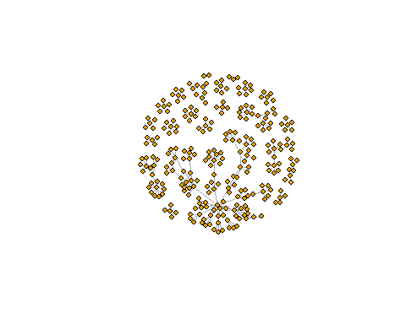

externe_2017_2 = externe_2017[,c("n_poste", "ID")]  
head(externe_2017_2)

## n_poste ID  
## 1 4283 82292477  
## 2 544 156891824  
## 3 4061 28820649  
## 4 4372 28820649  
## 5 4265 135608104  
## 6 901 35326727

graph_externe_2017 <- graph_from_data_frame(externe_2017_2, directed = FALSE)

## Warning in graph_from_data_frame(externe_2017_2, directed = FALSE): In `d' `NA'  
## elements were replaced with string "NA"

V(graph_externe_2017)$label <- V(graph_externe_2017)$name # set labels.  
plot(graph_externe_2017, vertex.label = NA, vertex.size = 7)

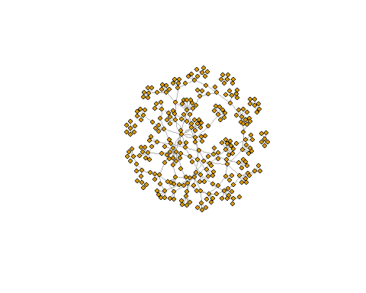

interne_2018_2 = interne_2018[,c("n_poste", "ID")]  
head(interne_2018_2)

## n_poste ID  
## 1 4191 3376199X  
## 2 4551 103593462  
## 3 4551 103593462  
## 4 4438 195926226  
## 5 43 12146489X  
## 6 4410 119644312

graph_interne_2018 <- graph_from_data_frame(interne_2018_2, directed = FALSE)

## Warning in graph_from_data_frame(interne_2018_2, directed = FALSE): In `d' `NA'  
## elements were replaced with string "NA"

V(graph_interne_2018)$label <- V(graph_interne_2018)$name # set labels.  
plot(graph_interne_2018, vertex.label = NA, vertex.size = 7)

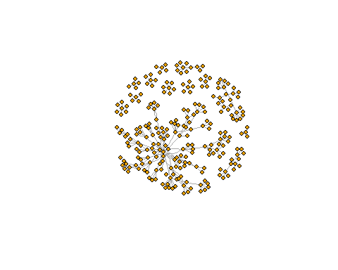

externe_2018_2 = externe_2018[,c("n_poste", "ID")]  
head(externe_2018_2)

## n_poste ID  
## 1 645 30023459  
## 2 4559 30023459  
## 3 4410 34223940  
## 4 4063 28820649  
## 5 4303 28820649  
## 6 645 148123007

graph_externe_2018 <- graph_from_data_frame(externe_2018_2, directed = FALSE)

## Warning in graph_from_data_frame(externe_2018_2, directed = FALSE): In `d' `NA'  
## elements were replaced with string "NA"

V(graph_externe_2018)$label <- V(graph_externe_2018)$name # set labels.  
plot(graph_externe_2018, vertex.label = NA, vertex.size = 7)

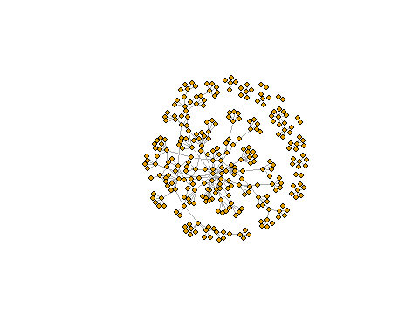

interne_2019_2 = interne_2019 [,c("n_poste", "ID")]  
head(interne_2019_2)

## n_poste ID  
## 1 4591 110135679  
## 2 56 82292477  
## 3 748 158187547  
## 4 4254 100503756  
## 5 4639 <NA>  
## 6 4639 <NA>

graph_interne_2019 <- graph_from_data_frame(interne_2019_2, directed = FALSE)

## Warning in graph_from_data_frame(interne_2019_2, directed = FALSE): In `d' `NA'  
## elements were replaced with string "NA"

V(graph_interne_2019)$label <- V(graph_interne_2019)$name # set labels.  
plot(graph_interne_2019, vertex.label = NA, vertex.size = 7)

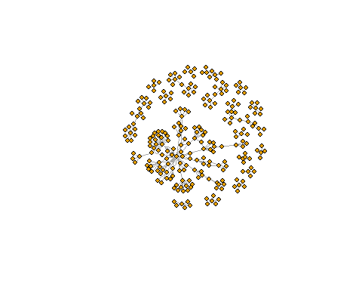

externe_2019_2 = externe_2019[,c("n_poste", "ID")]  
head(externe_2019_2)

## n_poste ID  
## 1 94 82292477  
## 2 322 82292477  
## 3 4376 34223940  
## 4 4460 <NA>  
## 5 381 50726129  
## 6 1087 50726129

graph_externe_2019 <- graph_from_data_frame(externe_2019_2, directed = FALSE)

## Warning in graph_from_data_frame(externe_2019_2, directed = FALSE): In `d' `NA'  
## elements were replaced with string "NA"

V(graph_externe_2019)$label <- V(graph_externe_2019)$name # set labels.  
plot(graph_externe_2019, vertex.label = NA, vertex.size = 7)

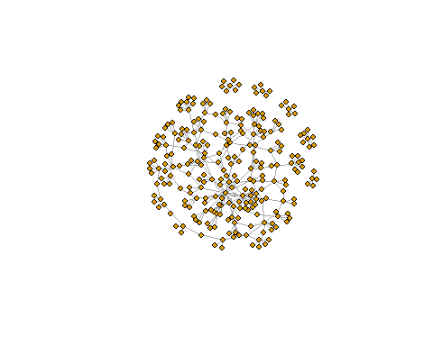

interne_2020_2 = interne_2020[,c("n_poste", "ID")]  
  
head(interne_2020_2)

## n_poste ID  
## 1 20 11317022X  
## 2 4636 194969770  
## 3 125 82292477  
## 4 160 82292477  
## 5 43 34223940  
## 6 4772 78972485

graph_interne_2020 <- graph_from_data_frame(interne_2020_2, directed = FALSE)

## Warning in graph_from_data_frame(interne_2020_2, directed = FALSE): In `d' `NA'  
## elements were replaced with string "NA"

V(graph_interne_2020)$label <- V(graph_interne_2020)$name # set labels.  
plot(graph_interne_2020, vertex.label = NA, vertex.size = 7)

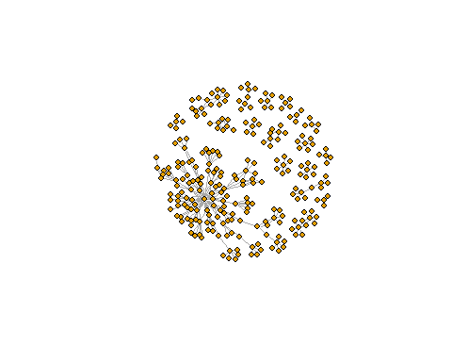

externe_2020_2 = externe_2020[,c("n_poste", "ID")]  
head(externe_2020_2)

## n_poste ID  
## 1 62 70549923  
## 2 4279 159017920  
## 3 4647 6993696X  
## 4 361 129974641  
## 5 4647 <NA>  
## 6 4543 58920943

graph_externe_2020 <- graph_from_data_frame(externe_2020_2, directed = FALSE)

## Warning in graph_from_data_frame(externe_2020_2, directed = FALSE): In `d' `NA'  
## elements were replaced with string "NA"

V(graph_externe_2020)$label <- V(graph_externe_2020)$name # set labels.  
plot(graph_externe_2020, vertex.label = NA, vertex.size = 7)

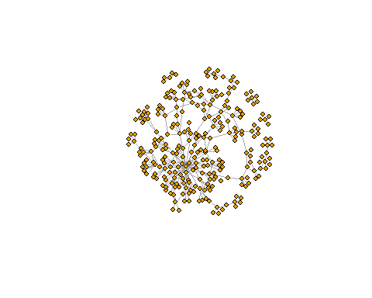

# Use igraph to make the graph and find membership  
wc <- cluster_walktrap(graph_interne_2017)  
members <- membership(wc)  
head(wc)

## $`1`  
## [1] "545" "570" "589" "31984967" "156924889" "78013992"   
## [7] "92157548" "34085564" "77902033" "59817941" "75134616" "59818085"   
## [13] "157131696" "8602681X" "66908671"   
##   
## $`2`  
## [1] "191" "192" "156891824" "71567895" "121324958" "147807018"  
## [7] "31994652" "67011136" "79359914" "115551522"  
##   
## $`3`  
## [1] "4314" "901" "4197" "4198" "35587865" "NA"   
## [7] "15212358X" "59941197" "58477446" "70561168" "19683273X" "95210865"   
## [13] "61072435" "80560563" "73368202" "123622352" "59427183" "69094586"   
##   
## $`4`  
## [1] "4380" "4361" "7957047X" "2858435X" "60459085" "13329434X"  
## [7] "35446331" "35059087" "34748679" "71470077" "136699839"  
##   
## $`5`  
## [1] "4284" "4286" "50284150" "35094478" "129783838" "81784805"   
## [7] "87519909" "157447596" "84598425" "138784434"  
##   
## $`6`  
## [1] "4421" "4420" "92460003" "73460907" "50245651" "33335273"   
## [7] "29083745" "96283653" "67729029" "13608043X"

head(members)

## 193 4314 54 4380 4361 4284   
## 13 3 34 4 4 5

# Convert to object suitable for networkD3  
graph_interne_2017_d3 <- igraph_to_networkD3(graph_interne_2017, group = members)  
graph_interne_2017_d3

## $links  
## source target  
## 1 52 258  
## 2 9 96  
## 3 26 80  
## 4 35 271  
## 5 15 65  
## 6 37 155  
## 7 7 262  
## 8 0 245  
## 9 30 87  
## 10 50 185  
## 11 26 161  
## 12 15 157  
## 13 9 252  
## 14 28 84  
## 15 36 210  
## 16 32 210  
## 17 11 82  
## 18 45 215  
## 19 42 215  
## 20 37 186  
## 21 9 73  
## 22 29 122  
## 23 6 127  
## 24 35 95  
## 25 23 248  
## 26 2 56  
## 27 29 85  
## 28 16 250  
## 29 3 174  
## 30 10 253  
## 31 27 246  
## 32 3 277  
## 33 31 209  
## 34 0 209  
## 35 6 243  
## 36 0 90  
## 37 31 90  
## 38 20 71  
## 39 11 259  
## 40 17 135  
## 41 21 140  
## 42 14 103  
## 43 28 131  
## 44 0 131  
## 45 10 62  
## 46 35 107  
## 47 36 273  
## 48 13 264  
## 49 19 69  
## 50 13 64  
## 51 50 191  
## 52 46 269  
## 53 7 59  
## 54 37 100  
## 55 38 100  
## 56 33 227  
## 57 43 276  
## 58 6 188  
## 59 13 166  
## 60 15 180  
## 61 8 93  
## 62 9 70  
## 63 44 203  
## 64 41 190  
## 65 43 211  
## 66 15 222  
## 67 14 168  
## 68 37 168  
## 69 26 86  
## 70 40 104  
## 71 13 254  
## 72 0 94  
## 73 31 94  
## 74 43 177  
## 75 8 60  
## 76 8 116  
## 77 19 141  
## 78 40 118  
## 79 22 206  
## 80 12 236  
## 81 46 183  
## 82 41 275  
## 83 3 112  
## 84 12 63  
## 85 11 63  
## 86 29 176  
## 87 18 197  
## 88 9 129  
## 89 20 241  
## 90 11 151  
## 91 29 165  
## 92 46 165  
## 93 23 175  
## 94 21 163  
## 95 23 77  
## 96 20 119  
## 97 34 92  
## 98 33 92  
## 99 28 150  
## 100 7 150  
## 101 16 76  
## 102 41 233  
## 103 32 136  
## 104 43 221  
## 105 31 221  
## 106 0 221  
## 107 46 159  
## 108 17 125  
## 109 27 182  
## 110 21 152  
## 111 23 117  
## 112 41 114  
## 113 17 137  
## 114 9 61  
## 115 33 148  
## 116 51 204  
## 117 17 198  
## 118 4 256  
## 119 49 217  
## 120 11 223  
## 121 35 160  
## 122 48 230  
## 123 40 240  
## 124 25 205  
## 125 4 238  
## 126 44 124  
## 127 5 72  
## 128 15 72  
## 129 6 72  
## 130 0 278  
## 131 26 134  
## 132 40 102  
## 133 16 66  
## 134 23 224  
## 135 41 226  
## 136 4 201  
## 137 3 201  
## 138 1 54  
## 139 18 171  
## 140 27 171  
## 141 5 58  
## 142 6 58  
## 143 10 99  
## 144 17 67  
## 145 24 192  
## 146 39 192  
## 147 20 202  
## 148 21 74  
## 149 47 249  
## 150 25 79  
## 151 25 225  
## 152 39 101  
## 153 30 101  
## 154 22 232  
## 155 14 242  
## 156 49 162  
## 157 16 268  
## 158 24 78  
## 159 8 142  
## 160 1 105  
## 161 48 172  
## 162 17 265  
## 163 1 219  
## 164 11 115  
## 165 12 115  
## 166 34 194  
## 167 34 220  
## 168 19 97  
## 169 0 88  
## 170 31 88  
## 171 4 144  
## 172 40 144  
## 173 43 121  
## 174 22 247  
## 175 1 145  
## 176 11 187  
## 177 11 147  
## 178 36 98  
## 179 15 126  
## 180 47 196  
## 181 17 110  
## 182 38 239  
## 183 28 207  
## 184 18 235  
## 185 52 263  
## 186 42 229  
## 187 47 156  
## 188 2 266  
## 189 10 106  
## 190 17 138  
## 191 15 270  
## 192 22 75  
## 193 42 132  
## 194 45 132  
## 195 4 257  
## 196 7 81  
## 197 0 81  
## 198 1 208  
## 199 9 83  
## 200 18 83  
## 201 27 83  
## 202 48 158  
## 203 13 130  
## 204 13 237  
## 205 29 216  
## 206 50 213  
## 207 34 218  
## 208 30 111  
## 209 24 111  
## 210 2 146  
## 211 43 251  
## 212 32 91  
## 213 25 169  
## 214 9 154  
## 215 50 193  
## 216 34 149  
## 217 33 149  
## 218 38 149  
## 219 37 149  
## 220 14 228  
## 221 37 228  
## 222 33 120  
## 223 14 199  
## 224 10 272  
## 225 9 108  
## 226 28 260  
## 227 40 113  
## 228 4 57  
## 229 3 57  
## 230 31 53  
## 231 0 53  
## 232 45 179  
## 233 5 164  
## 234 17 128  
## 235 2 167  
## 236 8 109  
## 237 5 195  
## 238 39 231  
## 239 15 139  
## 240 16 189  
## 241 34 234  
## 242 22 153  
## 243 29 244  
## 244 41 184  
## 245 6 178  
## 246 26 170  
## 247 17 170  
## 248 48 267  
## 249 33 123  
## 250 38 123  
## 251 18 68  
## 252 12 133  
## 253 11 133  
## 254 21 214  
## 255 32 255  
## 256 36 255  
## 257 35 274  
## 258 19 143  
## 259 23 89  
## 260 18 212  
## 261 49 173  
## 262 9 181  
## 263 46 200  
## 264 52 261  
## 265 45 55  
## 266 45 55  
## 267 1 55  
## 268 46 55  
## 269 26 55  
## 270 11 55  
## 271 19 55  
## 272 14 55  
## 273 0 55  
## 274 11 55  
## 275 19 55  
## 276 1 55  
## 277 47 55  
## 278 42 55  
## 279 1 55  
## 280 52 55  
## 281 49 55  
## 282 1 55  
## 283 1 55  
## 284 19 55  
## 285 11 55  
##   
## $nodes  
## name group  
## 1 193 13  
## 2 4314 3  
## 3 54 34  
## 4 4380 4  
## 5 4361 4  
## 6 4284 5  
## 7 4286 5  
## 8 191 2  
## 9 4413 28  
## 10 4409 14  
## 11 4372 23  
## 12 4403 10  
## 13 4404 10  
## 14 4219 19  
## 15 543 9  
## 16 4285 16  
## 17 4265 26  
## 18 4305 15  
## 19 4421 6  
## 20 901 3  
## 21 4263 36  
## 22 909 27  
## 23 24 25  
## 24 4348 17  
## 25 4282 8  
## 26 4273 33  
## 27 4306 12  
## 28 4420 6  
## 29 192 2  
## 30 4400 22  
## 31 4268 8  
## 32 197 13  
## 33 4287 7  
## 34 545 1  
## 35 570 1  
## 36 195 24  
## 37 4291 7  
## 38 544 9  
## 39 589 1  
## 40 4283 8  
## 41 4398 21  
## 42 4501 18  
## 43 4197 3  
## 44 131 20  
## 45 4061 37  
## 46 4198 3  
## 47 4401 11  
## 48 4387 31  
## 49 4334 32  
## 50 4379 30  
## 51 13 35  
## 52 61 38  
## 53 4208 29  
## 54 80526470 13  
## 55 35587865 3  
## 56 NA 3  
## 57 130387304 34  
## 58 7957047X 4  
## 59 50284150 5  
## 60 156891824 2  
## 61 195926226 28  
## 62 33917264 14  
## 63 147882621 23  
## 64 28820649 10  
## 65 153090901 19  
## 66 11317022X 16  
## 67 35326727 26  
## 68 50516167 15  
## 69 92460003 6  
## 70 15212358X 3  
## 71 161881645 14  
## 72 140689125 36  
## 73 35094478 5  
## 74 127921575 14  
## 75 52207757 27  
## 76 70444013 25  
## 77 32102518 26  
## 78 3086352X 17  
## 79 57487383 8  
## 80 54377595 33  
## 81 111200326 12  
## 82 71567895 2  
## 83 123243874 10  
## 84 73460907 6  
## 85 121324958 2  
## 86 131830120 22  
## 87 17184808X 12  
## 88 117796840 8  
## 89 60272333 13  
## 90 95664629 17  
## 91 139721010 13  
## 92 76536645 7  
## 93 31984967 1  
## 94 161856004 28  
## 95 177208899 13  
## 96 129850128 24  
## 97 109224825 14  
## 98 59941197 3  
## 99 61507814 7  
## 100 5034403X 23  
## 101 156924889 1  
## 102 55382398 8  
## 103 35271183 21  
## 104 146739817 9  
## 105 175894574 21  
## 106 58477446 3  
## 107 69642052 23  
## 108 15012533X 24  
## 109 79109802 14  
## 110 84579498 28  
## 111 66867525 15  
## 112 75679248 8  
## 113 2858435X 4  
## 114 79500064 21  
## 115 33785538 18  
## 116 59734736 10  
## 117 195933664 28  
## 118 33533326 17  
## 119 224780697 21  
## 120 30956544 36  
## 121 78013992 1  
## 122 60839503 20  
## 123 129209872 22  
## 124 92157548 1  
## 125 35084030 37  
## 126 32550251 15  
## 127 61750166 16  
## 128 129783838 5  
## 129 84338962 15  
## 130 29367247 14  
## 131 74263536 19  
## 132 147807018 2  
## 133 70561168 3  
## 134 92685609 10  
## 135 35231157 12  
## 136 143392719 15  
## 137 32179790 7  
## 138 33844402 15  
## 139 6985923X 15  
## 140 85802638 16  
## 141 144233916 27  
## 142 19683273X 3  
## 143 57783209 28  
## 144 95210865 3  
## 145 60459085 4  
## 146 61072435 3  
## 147 75943735 34  
## 148 61234613 10  
## 149 34085564 1  
## 150 77902033 1  
## 151 31994652 2  
## 152 29790530 10  
## 153 33339694 27  
## 154 86451979 25  
## 155 77712986 14  
## 156 114332118 9  
## 157 69168954 31  
## 158 119049112 16  
## 159 7419139X 32  
## 160 32294883 11  
## 161 34852069 24  
## 162 118185330 12  
## 163 57253358 30  
## 164 30848644 27  
## 165 81784805 5  
## 166 30072700 11  
## 167 159196205 19  
## 168 84343702 34  
## 169 169041824 9  
## 170 77013808 33  
## 171 89490967 12  
## 172 50245651 6  
## 173 58935177 32  
## 174 97481114 30  
## 175 13329434X 4  
## 176 30285011 17  
## 177 28822099 22  
## 178 192685465 20  
## 179 87519909 5  
## 180 80560563 3  
## 181 160524946 16  
## 182 98310526 14  
## 183 33335273 6  
## 184 26794144 11  
## 185 87101203 18  
## 186 118185276 35  
## 187 125703937 9  
## 188 61110949 10  
## 189 157447596 5  
## 190 8580925X 26  
## 191 165819790 18  
## 192 153489324 35  
## 193 50714619 8  
## 194 77863186 35  
## 195 59817941 1  
## 196 84598425 5  
## 197 61782270 31  
## 198 29083745 6  
## 199 34495274 15  
## 200 78090539 9  
## 201 98582860 11  
## 202 35446331 4  
## 203 50744941 36  
## 204 162387598 37  
## 205 34124217 38  
## 206 35020636 33  
## 207 226903931 25  
## 208 67011136 2  
## 209 73368202 3  
## 210 136910645 13  
## 211 121416593 7  
## 212 166964778 20  
## 213 96283653 6  
## 214 74723758 35  
## 215 93052553 27  
## 216 123622352 3  
## 217 74685856 22  
## 218 3479719X 30  
## 219 75134616 1  
## 220 59427183 3  
## 221 59818085 1  
## 222 32203772 13  
## 223 167805223 16  
## 224 34818715 10  
## 225 35424141 17  
## 226 55326927 33  
## 227 35434198 18  
## 228 157131696 1  
## 229 77902092 9  
## 230 69094586 3  
## 231 34892125 32  
## 232 85671835 8  
## 233 56242956 25  
## 234 3215741X 18  
## 235 8602681X 1  
## 236 67729029 6  
## 237 26768801 10  
## 238 74263595 19  
## 239 35059087 4  
## 240 66908671 1  
## 241 34893962 21  
## 242 29368391 36  
## 243 56757328 9  
## 244 138784434 5  
## 245 86997181 22  
## 246 115892001 13  
## 247 13608043X 6  
## 248 60847719 25  
## 249 130361372 17  
## 250 52737446 31  
## 251 132805871 26  
## 252 76104885 20  
## 253 119170302 14  
## 254 133984001 23  
## 255 176553703 19  
## 256 93630832 7  
## 257 34748679 4  
## 258 71470077 4  
## 259 104499036 29  
## 260 142513016 10  
## 261 79359914 2  
## 262 99261723 29  
## 263 115551522 2  
## 264 69006601 29  
## 265 150987293 19  
## 266 59317213 15  
## 267 69260974 34  
## 268 89759567 32  
## 269 57362025 26  
## 270 154832383 11  
## 271 69940010 16  
## 272 112381170 24  
## 273 78455197 23  
## 274 15018963X 7  
## 275 95203346 24  
## 276 27078876 18  
## 277 157325709 20  
## 278 136699839 4  
## 279 35128445 13

#Create force directed network plot  
forceNetwork(  
Links = graph_interne_2017_d3$links,  
Nodes = graph_interne_2017_d3$nodes,  
Source = 'source',  
Target = 'target',  
NodeID = 'name',  
Group = 'group'  
)

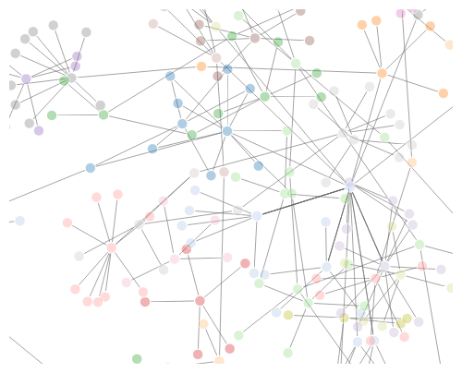

#part of degree strength...  
library(tidyverse)

## -- Attaching packages --------------------------------------- tidyverse 1.3.1 --

## v tibble 3.1.4 v stringr 1.4.0  
## v tidyr 1.1.4 v forcats 0.5.1  
## v purrr 0.3.4

## -- Conflicts ------------------------------------------ tidyverse_conflicts() --  
## x tibble::as_data_frame() masks dplyr::as_data_frame(), igraph::as_data_frame()  
## x purrr::compose() masks igraph::compose()  
## x tidyr::crossing() masks igraph::crossing()  
## x dplyr::filter() masks stats::filter()  
## x dplyr::groups() masks igraph::groups()  
## x dplyr::lag() masks stats::lag()  
## x purrr::simplify() masks igraph::simplify()

externe_2017_edge_list <- externe_2017 %>% dplyr::select(n_poste, ID) %>%  
 inner_join(., dplyr::select(., n_poste, ID), by = "n_poste") %>%  
 rename(ID1 = ID.x, ID2 = ID.y) %>%  
 filter(ID1 != ID2) %>%  
 unique %>%  
 arrange(n_poste)  
  
head(externe_2017_edge_list)

## n_poste ID1 ID2  
## 1 13 90444590 112729851  
## 2 13 90444590 143374885  
## 3 13 90444590 122818709  
## 4 13 90444590 136684459  
## 5 13 90444590 89759567  
## 6 13 112729851 90444590

# Plot  
#another one   
# simpleNetwork(externe_2017_edge_list[c('ID1', 'ID2')]) %>%  
# saveNetwork(file = 'externe_2017_edge_list_id.html')  
# #doesn't show anything after running

externe_2017_edge_list_name <- externe_2017 %>% dplyr::select(Level, n_poste, Name) %>%  
 inner_join(., dplyr::select(., n_poste, Name), by = "n_poste") %>%  
 rename(Name1 = Name.x, Name2 = Name.y) %>%  
 filter(Name1 != Name2) %>%  
 unique %>%  
 arrange(n_poste)  
  
head(externe_2017_edge_list_name)

## Level n_poste Name1 Name2  
## 1 MCF 13 Caroline DESOMBRE Claire PERRIN  
## 2 MCF 13 Caroline DESOMBRE Cyril CROZET  
## 3 MCF 13 Caroline DESOMBRE Dominique BERGER  
## 4 MCF 13 Caroline DESOMBRE Jeanine POMMIER  
## 5 MCF 13 Caroline DESOMBRE Thierry PIOT  
## 6 MCF 13 Claire PERRIN Caroline DESOMBRE

# Plot  
#  
# simpleNetwork(externe_2017_edge_list_name[c('Name1', 'Name2')]) %>%  
# saveNetwork(file = 'externe_2017_edge_list_name.html')

externe_2017_matrix_name <- as.matrix(externe_2017_edge_list_name[c('Name1', 'Name2')])

#multipartite graph colored by level of jury  
externe_2017$Level <- as.factor(externe_2017$Level)  
graph_externe_2017 <- graph_from_edgelist(externe_2017_matrix_name, directed = FALSE)  
plot(graph_externe_2017,  
 vertex.label = NA, vertex.size = 8, vertex.color = externe_2017$Level)

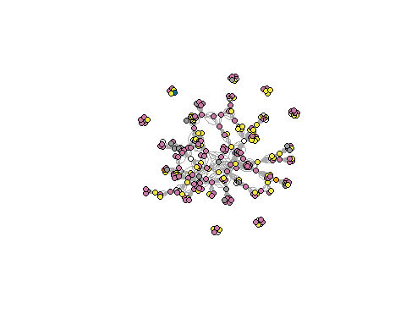

# Community Detection ----------------------------------------------------  
# Louvain  
#community detection external 2017  
lc_externe_2017 <- cluster_louvain(graph_externe_2017)  
membership(lc_externe_2017)

## Caroline DESOMBRE Claire PERRIN   
## 1 2   
## Cyril CROZET Dominique BERGER   
## 2 2   
## Jeanine POMMIER Thierry PIOT   
## 2 2   
## Christine Detrez Christine Musselin   
## 3 3   
## Fabienne Maillard Paul Olry   
## 3 3   
## Richard Wittorski Farinaz FASSA RECROSIO   
## 3 2   
## Marcel CALVEZ Olivier MEUNIER   
## 2 2   
## Dominique VIDAL Elisabeth CUNIN   
## 2 2   
## Francis DUPUY Line NUMA BOCAGE   
## 2 2   
## Marie-Louise MARTINEZ Valérie BECQUET   
## 2 2   
## Céline BUCHS Gilles DIEUMEGARD   
## 4 4   
## Laurent COSNEFROY Marie-Christine TOCZEK-CAPELLE   
## 4 4   
## Odile ROHMER Yves JEANNE   
## 4 4   
## Dominique BROUSSAL Frédéric SAUJAT   
## 5 5   
## Martine PAINDORGE Pascale BRANDT POMARES   
## 5 5   
## David BEDOURET David GIBAND   
## 6 6   
## Dominique CHEVALIER Geneviève CORTES   
## 6 6   
## Magali HARDOUIN Annette JARLEGAN   
## 6 1   
## Benoît DOMPNIER Bertrand DAUNAY   
## 1 1   
## Fabien FENOUILLET François LE GOFF   
## 1 1   
## Gersende PLISSONNEAU Laurence FILISETTI   
## 1 1   
## Michel BRAUD Nicole BIAGIOLI   
## 1 1   
## Sophie MORLAIX Cécile DE HOSSON   
## 1 7   
## Eric TRIQUET Ludovic MORGE   
## 7 7   
## Magali GALLEZOT Sandie BERNARD   
## 7 7   
## Laurence FILISETTI Denise ORANGE RAVACHOL RAVACHOL   
## 1 8   
## Jean-Marc LANGE Karine BÉCU-ROBINAULT   
## 7 7   
## LHOSTE Yann Philippe GIRARD   
## 7 7   
## Valérie MUNIER Alain JEAN   
## 7 9   
## Brigitte Marin Jean-Marie BURKHARDT   
## 9 9   
## Nathalie CATELLANI Nathalie Younes   
## 9 9   
## Stéphane SIMONIAN Catherine BLAYA   
## 9 1   
## Jean-Charles CHABANNE Loïc CLAVIER   
## 1 1   
## Marielle LE MENER Marion FABRE   
## 1 1   
## Carine SIMAR Gwenaëlle VIDAL-TRECAN   
## 10 10   
## Laurent LIMA Pierre LOMBRAIL   
## 10 10   
## Rémi GAGNAYRE Yves MATILLON   
## 10 10   
## Bruno DE LIEVRE Françoise POYET   
## 9 11   
## Jacques AUDRAN Anne BARRERE   
## 9 11   
## Céline CLEMENT Céline PIQUEE   
## 11 11   
## Emmanuel NAL Eric FLAVIER   
## 11 11   
## Marc WEISSER Marie-France BISHOP   
## 11 11   
## Béatrice SAVARIEAU Brigitte PAGNANI   
## 12 12   
## Emmanuel TRIBY Hélène BEZILLE LESQUOY   
## 12 12   
## Nacira AÏT-ABDESSELAM Alain VULBEAU   
## 12 2   
## Françoise BRÉANT Geneviève Bergonnier-Dupuy   
## 2 2   
## Jean-François Marcel Pascal MARQUET   
## 2 2   
## Pascal PANSU Roland GOIGOUX   
## 2 2   
## Bernard SARRAZY Didier JOURDAN   
## 2 2   
## Gilles COMBAZ Sylvie WHARTON   
## 2 2   
## Thérèse PEREZ-ROUX Aurélien SIRI   
## 2 2   
## Jean-Jacques SALONE Christophe Roiné   
## 2 13   
## Geneviève ZOIA Gilles MONCEAU   
## 14 13   
## Sylvain Starck Brigitte ALBERO   
## 13 14   
## Isabelle Astier Jean-Yves Authier   
## 14 14   
## Pascale Garnier Sandrine NICOURD   
## 14 14   
## Véronique BORDES Ghislaine GUEUDET   
## 14 9   
## Jean-Luc RINAUDO Vanda LUENGO   
## 15 9   
## Anne-Claire Husser Eric PRAIRAT   
## 16 16   
## Mathias Gardet Maxime Vanhoenacker   
## 16 16   
## Nathalie Montoya Sylvain Broccolichi   
## 16 16   
## Sylvie Condette Annette SCHMEHL POSTAI   
## 16 5   
## Annie JEZEGOU Antoine THEPAUT   
## 5 5   
## François Xavier BERNARD Frédéric CHARLES   
## 5 5   
## Martine JAUBERT Divina FRAU-MEIGS   
## 8 9   
## Isabelle VINATIER Jérôme GUÉRIN   
## 9 9   
## Denis BUTLEN Jean-Marie BOILEVIN   
## 7 7   
## Olivier LAS VERGNAS Abdelkarim ZAID   
## 7 9   
## Fabienne MAILLARD Gilles LECLERCQ   
## 9 9   
## Jean-François THEMINES Christine VIDAL-GOMEL   
## 9 9   
## Florence DESPRET Gilles BAILLAT   
## 9 9   
## Renaud D'ENFERT Bruno GARNIER   
## 9 11   
## Jerôme MBIATONG Laurent VISIER   
## 14 14   
## Patricia LONCLE Stéphanie RUBI   
## 14 14   
## Valérie MELIN Athanasios GAGATSIS   
## 14 5   
## Ecatérina PACURAR Emmanuelle VOULGRE   
## 5 5   
## Luc TROUCHE Nicolas DECAMP   
## 5 5   
## Philippe HOPPENOT Pierre-André CARON   
## 5 5   
## Joël BISAULT Magali HERSANT   
## 2 2   
## Marie-France CARNUS Denis LOIZON   
## 15 2   
## Serge LEBLANC Sigolène COUCHOT SCHIEX   
## 2 2   
## Charles HEIMBERG Dominique OTTAVI   
## 11 11   
## Fabienne BRIERE-GUENOUN Florence DARNIS   
## 11 11   
## Françoise LAOT Jean ST-MARTIN   
## 11 11   
## Jean TROHEL Monique LOQUET   
## 11 11   
## Nassira HEDJERASSI Christine VIDAL-GOMEL   
## 11 9   
## Geneviève LAMEUL Jérôme ENEAU   
## 9 9   
## Marie-Marie-Christine Félix C Jégou   
## 9 8   
## C Morin E Triquet   
## 8 8   
## H Tostivint L Maurines   
## 8 8   
## P Marzin Y Bassaglia   
## 8 8   
## Emmanuelle ANNOOT Marie-Pierre CHOPIN   
## 9 9   
## Pascale GARNIER Cathy Clenet   
## 9 13   
## Frédérique Lerbet-Sereni Luca Paltrinieri   
## 13 13   
## Martine Lani-Bayle Patricia Alonso   
## 13 13   
## Bruno POUCET Denis KAMBOUCHNER   
## 17 17   
## Isabelle QUEVAL Jean-François GOUBET   
## 17 17   
## Katia GENEL Sophie AUDIDIERE   
## 17 17   
## Frédérique LERBET-SÉRÉNI Frédérique MONTANDON   
## 2 2   
## Thierry ARDOUIN Thierry MICHALOT   
## 2 2   
## Emmanuel de Lescure Florence Mourlhon-Dallies   
## 18 18   
## Louis Durrive Magali Prost   
## 18 18   
## Pascal Roquet Jérôme Deauvieau   
## 18 11   
## Louis-André Vallet Régine Sirota   
## 11 11   
## Stéphane Bonnery Danièle PERISSET   
## 11 9   
## Éric RODITI Laurence DURAT   
## 9 9   
## Fanny SALANE Florence ELOY   
## 8 8   
## Mokhtar KADDOURI Pierre Périer   
## 8 8   
## Régine SIROTA Séverine CHAUVEL   
## 8 8   
## Antoine KATTAR Bernard Wentzel   
## 18 18   
## Marianne Woollven Sandrine Croity-Belz   
## 18 18   
## Sylvie Canat Guillaume Sibertin-Blanc   
## 18 13   
## Hélène Bezille Olivier Brito   
## 13 13   
## Silke Schauder Xavier RIONDET   
## 13 13   
## Chantal Zaouche Florence LABRELL   
## 8 8   
## Florian OUITRE Jean-Yves Rochex   
## 8 8   
## Mathilde MUSARD Stéphane BRAU-ANTONY   
## 8 8   
## Béatrice MABILON BONFILS Christine Mias   
## 7 7   
## Catherine DORISON Élise TENRET   
## 15 15   
## Frédéric RASERA Ilaria PIRONE   
## 15 15   
## Léandro DE LAJONQUIERE Lucile LAFONT   
## 15 15   
## Minna PUUSTINEN Sophie LERNER-SEI   
## 15 15   
## Bernard CALMETTES Caroline LADAGE   
## 7 7   
## Patricia MERCADER Philippe CHAUSSECOURTE   
## 2 2   
## Lydie LAROQUE Matthieu LETOURNEUX   
## 11 11   
## Myriam TSIMBIDY Philippe CLERMONT   
## 11 11   
## Yann MERCIER-BRUNEL Séverine DEPOILLY   
## 11 9

communities(lc_externe_2017)

## $`1`  
## [1] "Caroline DESOMBRE" "Annette JARLEGAN" "Benoît DOMPNIER"   
## [4] "Bertrand DAUNAY" "Fabien FENOUILLET" "François LE GOFF"   
## [7] "Gersende PLISSONNEAU" "Laurence FILISETTI" "Michel BRAUD"   
## [10] "Nicole BIAGIOLI" "Sophie MORLAIX" "Laurence FILISETTI"   
## [13] "Catherine BLAYA" "Jean-Charles CHABANNE" "Loïc CLAVIER"   
## [16] "Marielle LE MENER" "Marion FABRE"   
##   
## $`2`  
## [1] "Claire PERRIN" "Cyril CROZET"   
## [3] "Dominique BERGER" "Jeanine POMMIER"   
## [5] "Thierry PIOT" "Farinaz FASSA RECROSIO"   
## [7] "Marcel CALVEZ" "Olivier MEUNIER"   
## [9] "Dominique VIDAL" "Elisabeth CUNIN"   
## [11] "Francis DUPUY" "Line NUMA BOCAGE"   
## [13] "Marie-Louise MARTINEZ" "Valérie BECQUET"   
## [15] "Alain VULBEAU" "Françoise BRÉANT"   
## [17] "Geneviève Bergonnier-Dupuy" "Jean-François Marcel"   
## [19] "Pascal MARQUET" "Pascal PANSU"   
## [21] "Roland GOIGOUX" "Bernard SARRAZY"   
## [23] "Didier JOURDAN" "Gilles COMBAZ"   
## [25] "Sylvie WHARTON" "Thérèse PEREZ-ROUX"   
## [27] "Aurélien SIRI" "Jean-Jacques SALONE"   
## [29] "Joël BISAULT" "Magali HERSANT"   
## [31] "Denis LOIZON" "Serge LEBLANC"   
## [33] "Sigolène COUCHOT SCHIEX" "Frédérique LERBET-SÉRÉNI"   
## [35] "Frédérique MONTANDON" "Thierry ARDOUIN"   
## [37] "Thierry MICHALOT" "Patricia MERCADER"   
## [39] "Philippe CHAUSSECOURTE"   
##   
## $`3`  
## [1] "Christine Detrez" "Christine Musselin" "Fabienne Maillard"   
## [4] "Paul Olry" "Richard Wittorski"   
##   
## $`4`  
## [1] "Céline BUCHS" "Gilles DIEUMEGARD"   
## [3] "Laurent COSNEFROY" "Marie-Christine TOCZEK-CAPELLE"  
## [5] "Odile ROHMER" "Yves JEANNE"   
##   
## $`5`  
## [1] "Dominique BROUSSAL" "Frédéric SAUJAT"   
## [3] "Martine PAINDORGE" "Pascale BRANDT POMARES"   
## [5] "Annette SCHMEHL POSTAI" "Annie JEZEGOU"   
## [7] "Antoine THEPAUT" "François Xavier BERNARD"  
## [9] "Frédéric CHARLES" "Athanasios GAGATSIS"   
## [11] "Ecatérina PACURAR" "Emmanuelle VOULGRE"   
## [13] "Luc TROUCHE" "Nicolas DECAMP"   
## [15] "Philippe HOPPENOT" "Pierre-André CARON"   
##   
## $`6`  
## [1] "David BEDOURET" "David GIBAND" "Dominique CHEVALIER"  
## [4] "Geneviève CORTES" "Magali HARDOUIN"   
##   
## $`7`  
## [1] "Cécile DE HOSSON" "Eric TRIQUET"   
## [3] "Ludovic MORGE" "Magali GALLEZOT"   
## [5] "Sandie BERNARD" "Jean-Marc LANGE"   
## [7] "Karine BÉCU-ROBINAULT" "LHOSTE Yann"   
## [9] "Philippe GIRARD" "Valérie MUNIER"   
## [11] "Denis BUTLEN" "Jean-Marie BOILEVIN"   
## [13] "Olivier LAS VERGNAS" "Béatrice MABILON BONFILS"  
## [15] "Christine Mias" "Bernard CALMETTES"   
## [17] "Caroline LADAGE"   
##   
## $`8`  
## [1] "Denise ORANGE RAVACHOL RAVACHOL" "Martine JAUBERT"   
## [3] "C Jégou" "C Morin"   
## [5] "E Triquet" "H Tostivint"   
## [7] "L Maurines" "P Marzin"   
## [9] "Y Bassaglia" "Fanny SALANE"   
## [11] "Florence ELOY" "Mokhtar KADDOURI"   
## [13] "Pierre Périer" "Régine SIROTA"   
## [15] "Séverine CHAUVEL" "Chantal Zaouche"   
## [17] "Florence LABRELL" "Florian OUITRE"   
## [19] "Jean-Yves Rochex" "Mathilde MUSARD"   
## [21] "Stéphane BRAU-ANTONY"   
##   
## $`9`  
## [1] "Alain JEAN" "Brigitte Marin"   
## [3] "Jean-Marie BURKHARDT" "Nathalie CATELLANI"   
## [5] "Nathalie Younes" "Stéphane SIMONIAN"   
## [7] "Bruno DE LIEVRE" "Jacques AUDRAN"   
## [9] "Ghislaine GUEUDET" "Vanda LUENGO"   
## [11] "Divina FRAU-MEIGS" "Isabelle VINATIER"   
## [13] "Jérôme GUÉRIN" "Abdelkarim ZAID"   
## [15] "Fabienne MAILLARD" "Gilles LECLERCQ"   
## [17] "Jean-François THEMINES" "Christine VIDAL-GOMEL "   
## [19] "Florence DESPRET" "Gilles BAILLAT"   
## [21] "Renaud D'ENFERT" "Christine VIDAL-GOMEL"   
## [23] "Geneviève LAMEUL" "Jérôme ENEAU"   
## [25] "Marie-Marie-Christine Félix" "Emmanuelle ANNOOT"   
## [27] "Marie-Pierre CHOPIN" "Pascale GARNIER"   
## [29] "Danièle PERISSET" "Éric RODITI"   
## [31] "Laurence DURAT" "Séverine DEPOILLY"   
##   
## $`10`  
## [1] "Carine SIMAR" "Gwenaëlle VIDAL-TRECAN" "Laurent LIMA"   
## [4] "Pierre LOMBRAIL" "Rémi GAGNAYRE" "Yves MATILLON"   
##   
## $`11`  
## [1] "Françoise POYET" "Anne BARRERE"   
## [3] "Céline CLEMENT" "Céline PIQUEE"   
## [5] "Emmanuel NAL" "Eric FLAVIER"   
## [7] "Marc WEISSER" "Marie-France BISHOP"   
## [9] "Bruno GARNIER" "Charles HEIMBERG"   
## [11] "Dominique OTTAVI" "Fabienne BRIERE-GUENOUN"  
## [13] "Florence DARNIS" "Françoise LAOT"   
## [15] "Jean ST-MARTIN" "Jean TROHEL"   
## [17] "Monique LOQUET" "Nassira HEDJERASSI"   
## [19] "Jérôme Deauvieau" "Louis-André Vallet"   
## [21] "Régine Sirota" "Stéphane Bonnery"   
## [23] "Lydie LAROQUE" "Matthieu LETOURNEUX"   
## [25] "Myriam TSIMBIDY" "Philippe CLERMONT"   
## [27] "Yann MERCIER-BRUNEL"   
##   
## $`12`  
## [1] "Béatrice SAVARIEAU" "Brigitte PAGNANI" "Emmanuel TRIBY"   
## [4] "Hélène BEZILLE LESQUOY" "Nacira AÏT-ABDESSELAM"   
##   
## $`13`  
## [1] "Christophe Roiné" "Gilles MONCEAU"   
## [3] "Sylvain Starck" "Cathy Clenet"   
## [5] "Frédérique Lerbet-Sereni" "Luca Paltrinieri"   
## [7] "Martine Lani-Bayle" "Patricia Alonso"   
## [9] "Guillaume Sibertin-Blanc" "Hélène Bezille"   
## [11] "Olivier Brito" "Silke Schauder"   
## [13] "Xavier RIONDET"   
##   
## $`14`  
## [1] "Geneviève ZOIA" "Brigitte ALBERO" "Isabelle Astier"   
## [4] "Jean-Yves Authier" "Pascale Garnier" "Sandrine NICOURD"   
## [7] "Véronique BORDES" "Jerôme MBIATONG" "Laurent VISIER"   
## [10] "Patricia LONCLE" "Stéphanie RUBI" "Valérie MELIN"   
##   
## $`15`  
## [1] "Jean-Luc RINAUDO" "Marie-France CARNUS" "Catherine DORISON"   
## [4] "Élise TENRET" "Frédéric RASERA" "Ilaria PIRONE"   
## [7] "Léandro DE LAJONQUIERE" "Lucile LAFONT" "Minna PUUSTINEN"   
## [10] "Sophie LERNER-SEI"   
##   
## $`16`  
## [1] "Anne-Claire Husser" "Eric PRAIRAT" "Mathias Gardet"   
## [4] "Maxime Vanhoenacker" "Nathalie Montoya" "Sylvain Broccolichi"  
## [7] "Sylvie Condette"   
##   
## $`17`  
## [1] "Bruno POUCET" "Denis KAMBOUCHNER" "Isabelle QUEVAL"   
## [4] "Jean-François GOUBET" "Katia GENEL" "Sophie AUDIDIERE"   
##   
## $`18`  
## [1] "Emmanuel de Lescure" "Florence Mourlhon-Dallies"  
## [3] "Louis Durrive" "Magali Prost"   
## [5] "Pascal Roquet" "Antoine KATTAR"   
## [7] "Bernard Wentzel" "Marianne Woollven"   
## [9] "Sandrine Croity-Belz" "Sylvie Canat"

plot(lc_externe_2017, graph_externe_2017, vertex.label = NA, vertex.size = 1)

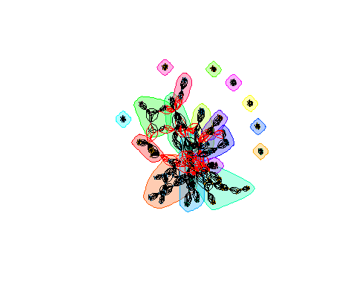

# Community Detection ----------------------------------------------------  
# Infomap  
# imc_externe <- cluster_infomap(graph_externe)  
# membership(imc_externe)  
# communities(imc_externe)  
# plot(imc_externe, lc_externe, vertex.label = NA, vertex.size = 8)

externe_edge_list_name <- externe %>% dplyr::select(n_poste, Name) %>%  
 inner_join(., dplyr::select(., n_poste, Name), by = "n_poste") %>%  
 rename(Name1 = Name.x, Name2 = Name.y) %>%  
 filter(Name1 != Name2) %>%  
 unique %>%  
 arrange(n_poste)  
  
head(externe_edge_list_name)

## n_poste Name1 Name2  
## 1 13 Caroline DESOMBRE Claire PERRIN  
## 2 13 Caroline DESOMBRE Cyril CROZET  
## 3 13 Caroline DESOMBRE Dominique BERGER  
## 4 13 Caroline DESOMBRE Jeanine POMMIER  
## 5 13 Caroline DESOMBRE Thierry PIOT  
## 6 13 Claire PERRIN Caroline DESOMBRE

externe_matrix_name <- as.matrix(externe_edge_list_name[c('Name1', 'Name2')])

externe$Level <- as.factor(externe$Level)  
graph_externe <- graph_from_edgelist(externe_matrix_name, directed = FALSE)  
plot(graph_externe, vertex.label = NA, vertex.size = 8, vertex.color = externe$Level)

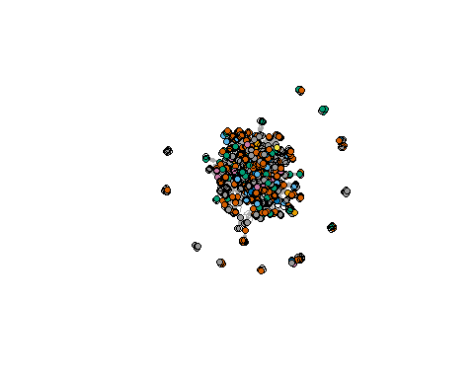

#there's a lot of overlapping

interne_2017_edge_list_name <- interne_2017 %>%dplyr:: select(Level, n_poste, Name) %>%  
 inner_join(., dplyr::select(., n_poste, Name), by = "n_poste") %>%  
 rename(Name1 = Name.x, Name2 = Name.y) %>%  
 filter(Name1 != Name2) %>%  
 unique %>%  
 arrange(n_poste)  
  
head(interne_2017_edge_list_name)

## Level n_poste Name1 Name2  
## 1 PU 13 Ludovic MORGE Marc DAGUZON  
## 2 PU 13 Ludovic MORGE Marie-Christine TOCZEK-CAPELLE  
## 3 PU 13 Ludovic MORGE Nathalie GAL-PETITFAUX  
## 4 MCF 13 Marc DAGUZON Ludovic MORGE  
## 5 MCF 13 Marc DAGUZON Marie-Christine TOCZEK-CAPELLE  
## 6 MCF 13 Marc DAGUZON Nathalie GAL-PETITFAUX

# Plot  
simpleNetwork(interne_2017_edge_list_name[c('Name1', 'Name2')]) %>%  
saveNetwork(file = 'interne_2017_edge_list_name.html')

interne_2017_matrix_name <- as.matrix(interne_2017_edge_list_name[c('Name1', 'Name2')])

#multipartite by color   
interne_2017$Level <- as.factor(interne_2017$Level)  
graph_interne_2017 <- graph_from_edgelist(interne_2017_matrix_name, directed = FALSE)  
plot(graph_interne_2017,  
 vertex.label = NA, vertex.size = 8, vertex.color = interne_2017$Level)

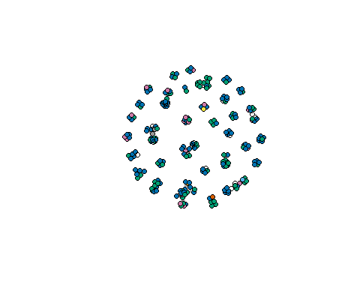

interne_edge_list_name <- interne %>% dplyr::select(Level, n_poste, Name) %>%  
 inner_join(., dplyr::select(., n_poste, Name), by = "n_poste") %>%  
 rename(Name1 = Name.x, Name2 = Name.y) %>%  
 filter(Name1 != Name2) %>%  
 unique %>%  
 arrange(n_poste)  
  
head(interne_edge_list_name)

## Level n_poste Name1 Name2  
## 1 PU 13 Ludovic MORGE Marc DAGUZON  
## 2 PU 13 Ludovic MORGE Marie-Christine TOCZEK-CAPELLE  
## 3 PU 13 Ludovic MORGE Nathalie GAL-PETITFAUX  
## 4 MCF 13 Marc DAGUZON Ludovic MORGE  
## 5 MCF 13 Marc DAGUZON Marie-Christine TOCZEK-CAPELLE  
## 6 MCF 13 Marc DAGUZON Nathalie GAL-PETITFAUX

interne_matrix_name <- as.matrix(interne_edge_list_name[c('Name1', 'Name2')])

# interne_2017_degree <- as.data.frame(degree(graph_interne_2017))  
# colnames(interne_2017_degree) <- c("degree")  
# interne_2017_degree <- interne_2017_degree %>% arrange(desc(degree))  
# head(interne_2017_degree)  
#   
# interne_2017_betweenness <- as.data.frame(betweenness(graph_interne_2017))  
# colnames(interne_2017_betweenness) <- c("betweenness")  
# interne_2017_betweenness <- interne_2017_betweenness %>% arrange(desc(betweenness))  
# head(interne_2017_betweenness)  
#   
# interne_2017_strength <- as.data.frame(strength(graph_interne_2017))  
# colnames(interne_2017_strength) <- c("strength")  
# interne_2017_strength <- interne_2017_strength %>% arrange(desc(strength))  
# head(interne_2017_strength)

graph_2017 <- graph_from_edgelist(interne_2017_matrix_name, directed = FALSE)  
plot(graph_2017,  
vertex.label = NA, vertex.size = betweenness(graph_2017))

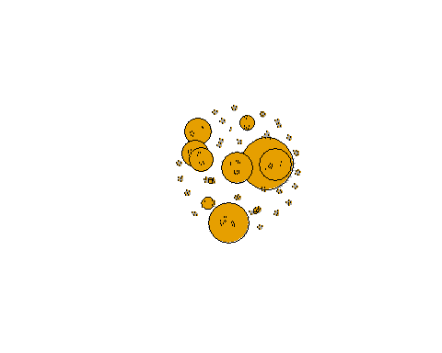

#change width   
graph_externe_2017 <- graph_from_edgelist(externe_2017_matrix_name, directed = FALSE)  
plot(graph_externe_2017,  
vertex.label = NA, vertex.size = betweenness(graph_externe_2017)*0.005)

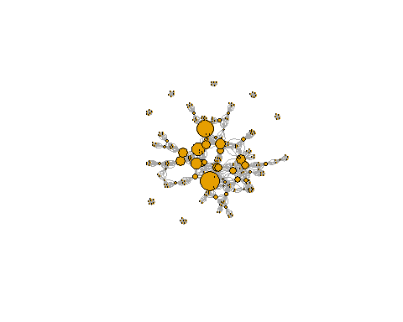

#change strength   
graph_externe_2017 <- graph_from_edgelist(externe_2017_matrix_name, directed = FALSE)  
plot(graph_externe_2017,  
vertex.label = NA, edge.width = strength(graph_externe_2017)*0.05, vertex.size = 8)

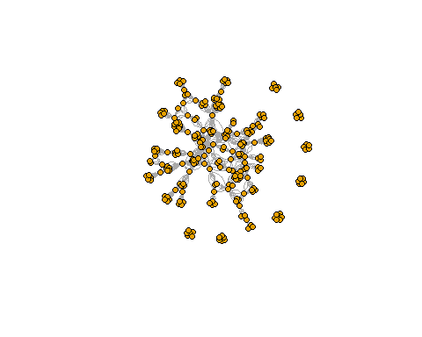

links <- data.frame(  
source = c("Bachelor 2", "Bachelor 2", "Bachelor 2", "Exchange 1", "Bachelor 3", "Bachelor 3"),  
target = c("Bachelor 3", "CY Tech", "Wild", "Bachelor 3", "Bachelor 4", "Exchange 2"),  
value = c(12, 5, 1, 5, 13, 4)  
)  
  
  
  
  
  
nodes <- data.frame(name = c(as.character(links$source), as.character(links$target)) %>% unique())  
  
  
  
  
  
  
links$ID.source <- match(links$source, nodes$name) - 1  
links$ID.target <- match(links$target, nodes$name) - 1

p <- sankeyNetwork(Links = links, Nodes = nodes, Source = "ID.source", Target = "ID.target", Value = "value", NodeID = "name", sinksRight = FALSE,fontSize = 15)  
  
  
  
  
  
p

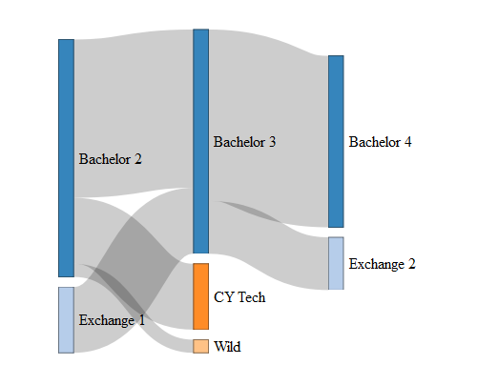

temp_graph <- graph.data.frame(links)  
adjaceny.matrix <- get.adjacency(temp_graph, sparse = FALSE, attr= "value")  
  
  
  
  
  
chordDiagram(adjaceny.matrix, transparency = 0.75)

